Online instructions for booking your COVID-19 Testing
All appointments must be booked at minimum two (2) hours in advance
Results take up to 48hrs to be processed and must be received by the surgery center prior to your scheduled surgery date.
You must present your physician signed OrthoSouth Laboratory Order form, copy of your driver’s license as well as your insurance card for COVID-19 testing to be performed
Go to www.ael.com
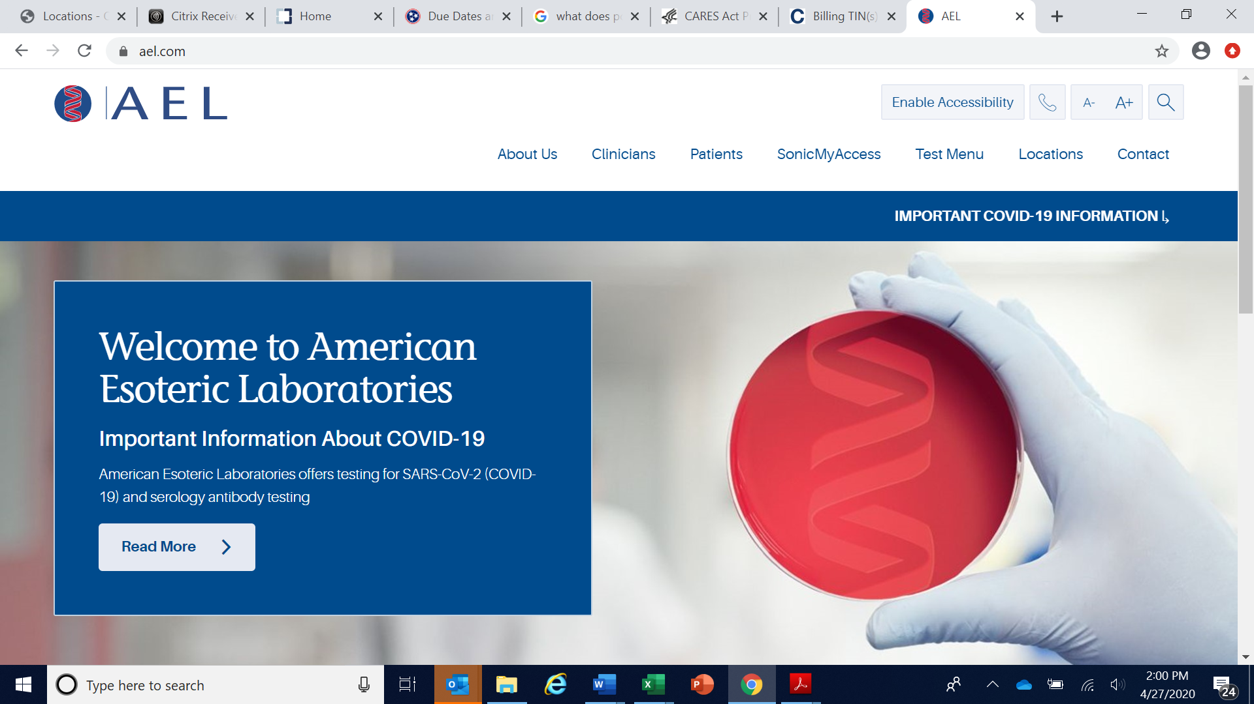

Select “Locations” from top right menu
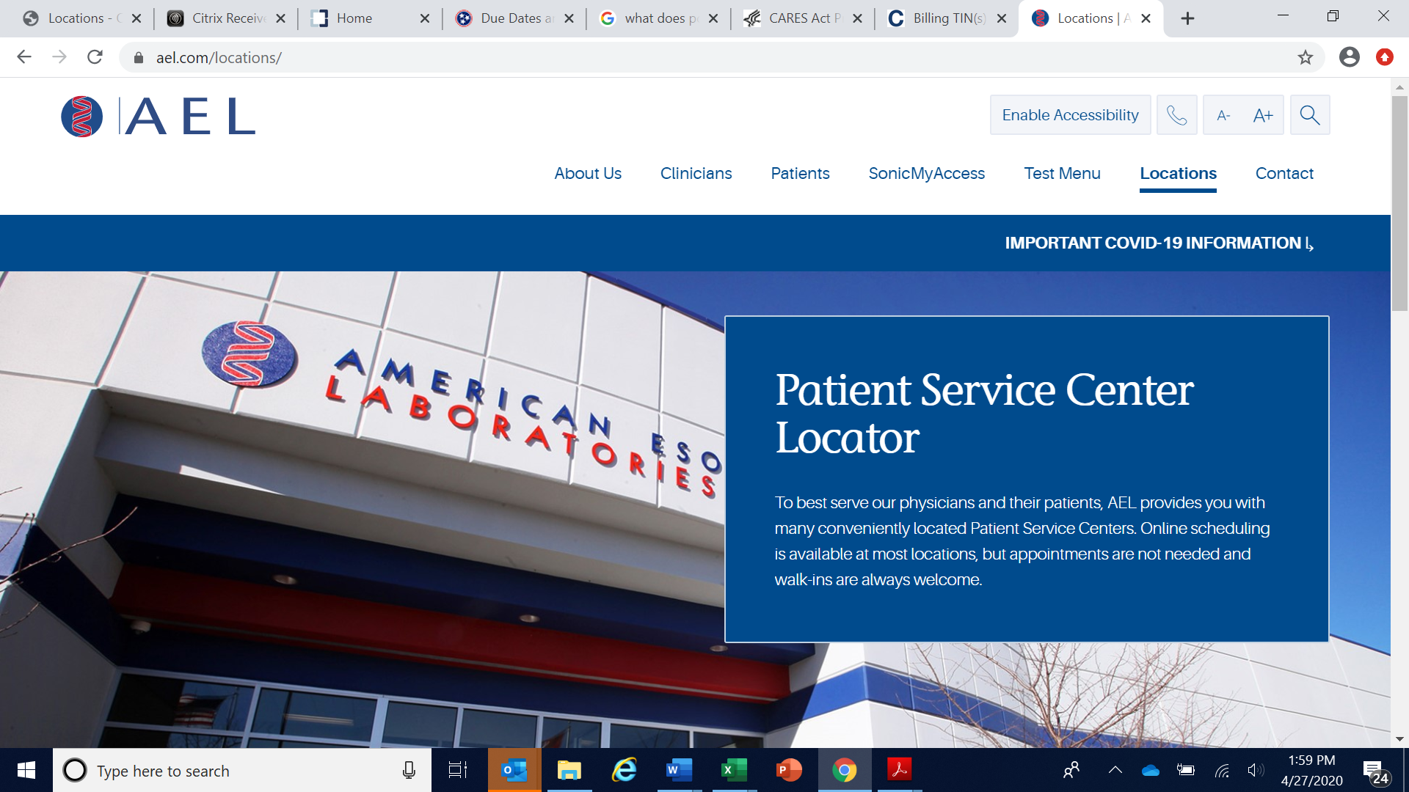

Scroll down to the bottom of the page to reveal all the AEL site locations listed on the right-hand side.
**VERY IMPORTANT**
There are ONLY four (4) COVID-19 test collections sites to choose from:
(2) Bartlett, TN – 7953 Stage Hills Blvd, Suite 105, Bartlett, TN 38133
(10) Desoto PSC – 391 Southcrest Circle, Suite 104, Southaven, MS 38671
(23) Memphis, TN – Germantown Rehab Hospital at 2100 Exeter Road, Germantown, TN 38138
(24) Memphis, TN – Humphreys at 80 Humphreys Blvd, Suite #108 Memphis, TN 38120
**THESE ARE THE ONLY COVID-19 TEST SITES, PLEASE MAKE SURE TO SELECT ONE OF THESE
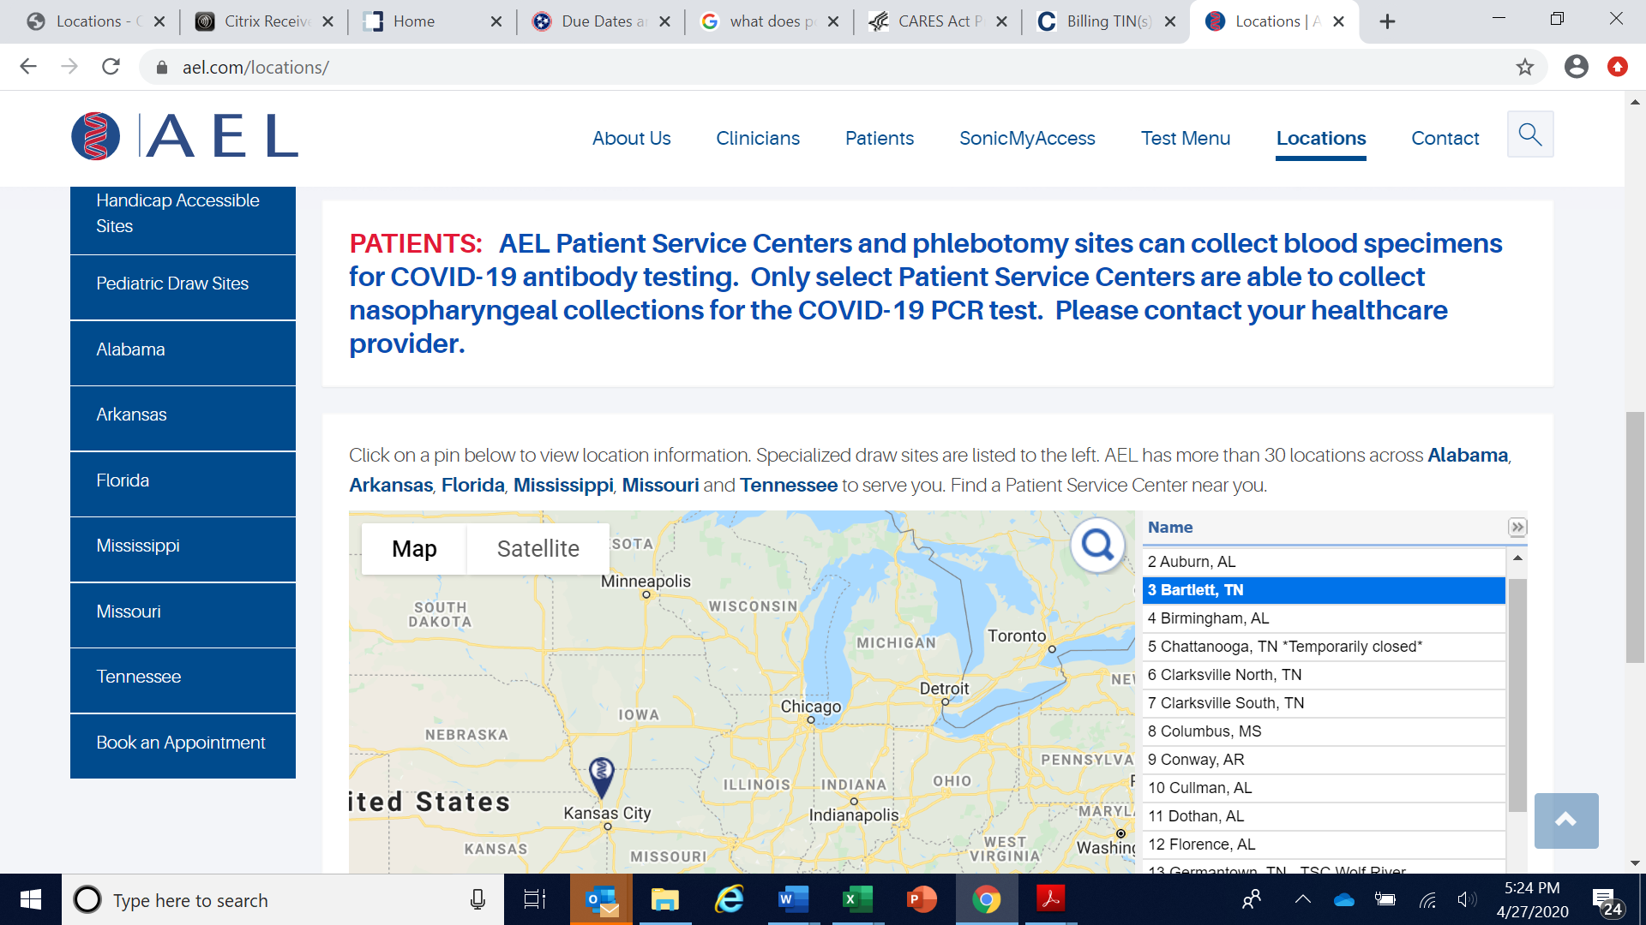
Click on your preferred site location and select “Book Appointment”
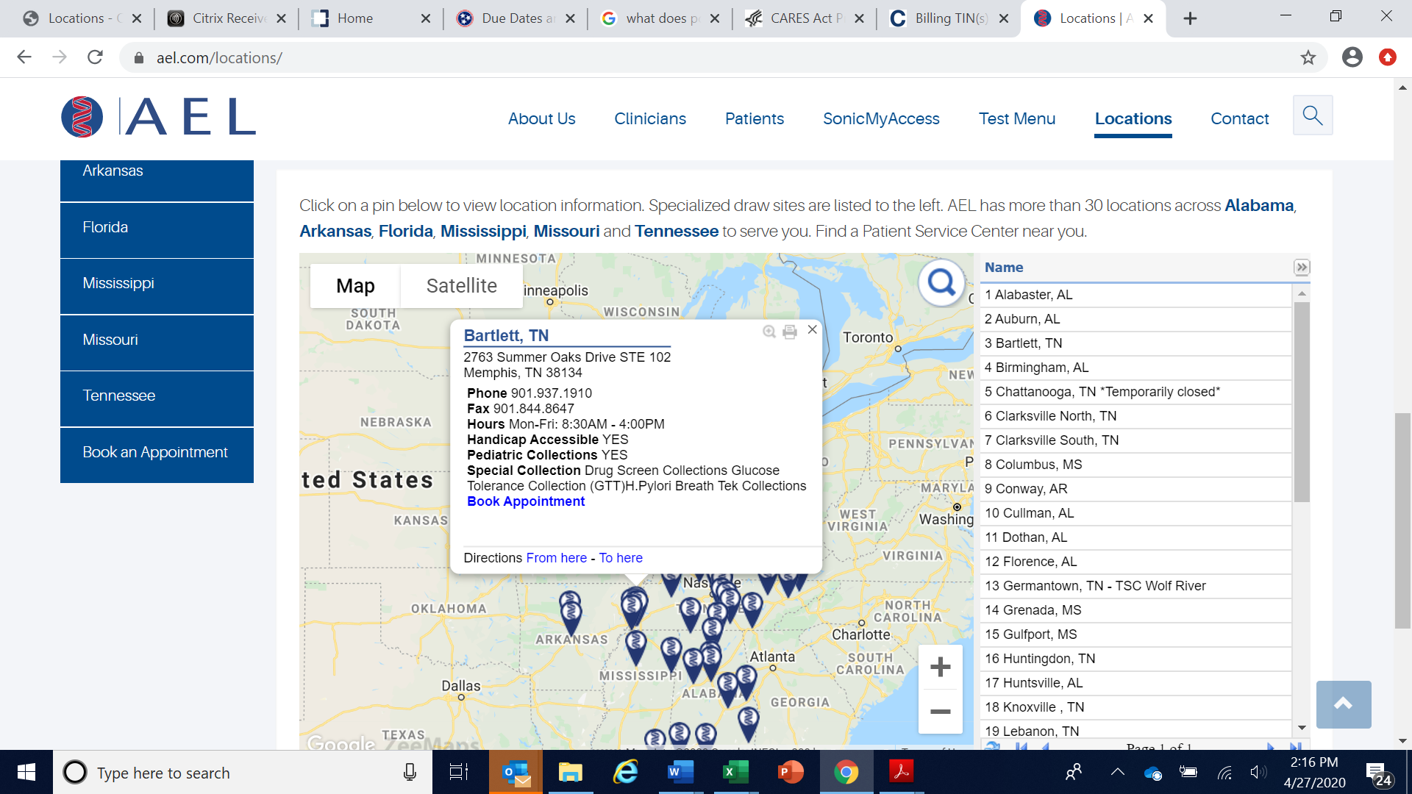
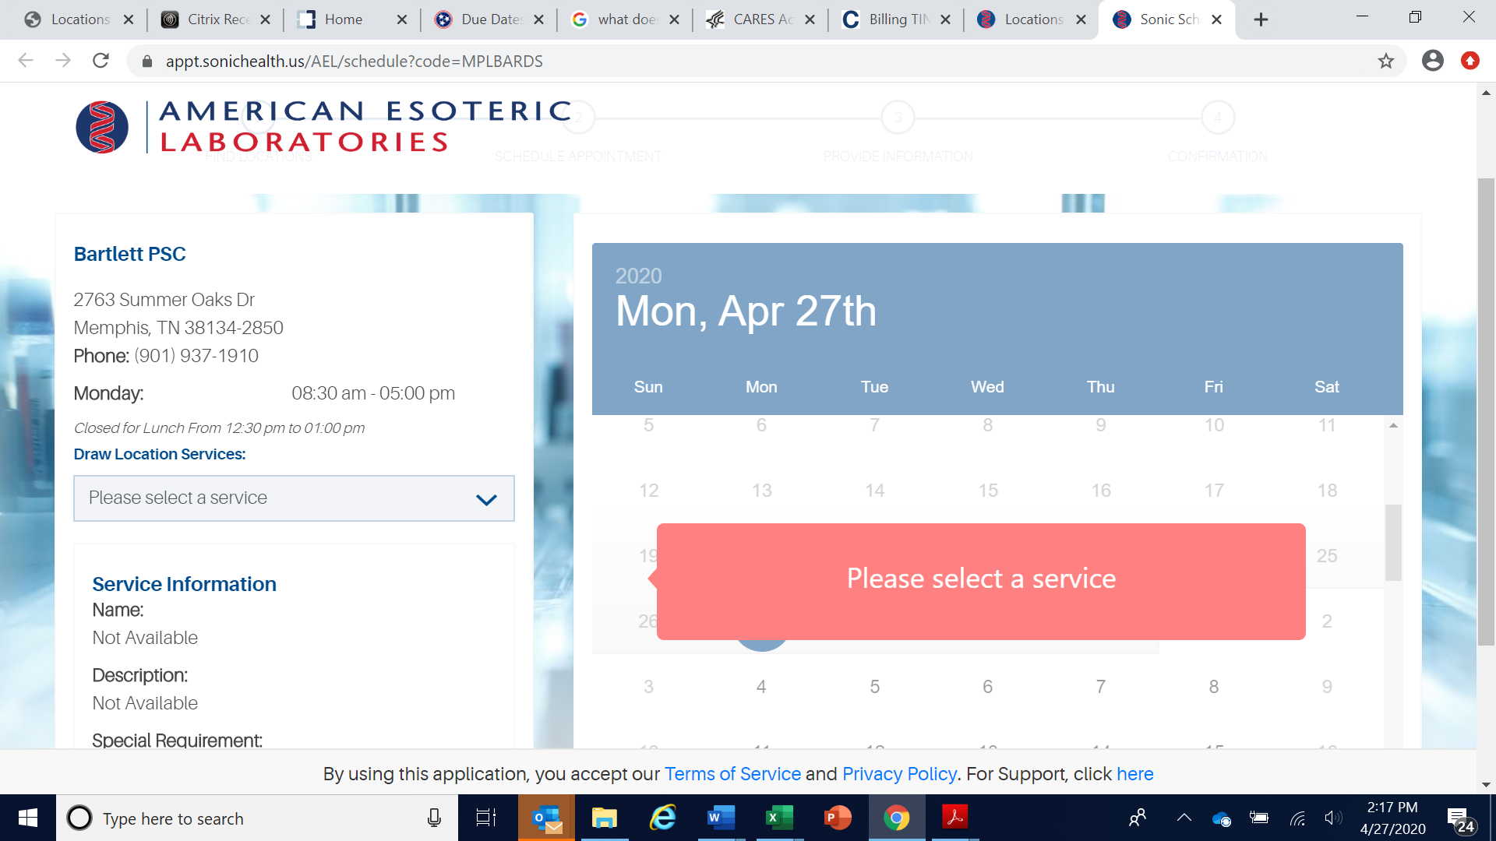
There will be a drop-down menu under “Draw Location Services” on the left-hand side of the screen
Please select “Nasopharyngeal COVID-19 Collections”
**IF YOU DO NOT SEE NASOPHARYNGEAL COVID-19 AS AN OPTION – ITS NOT AN APPROVED SITE

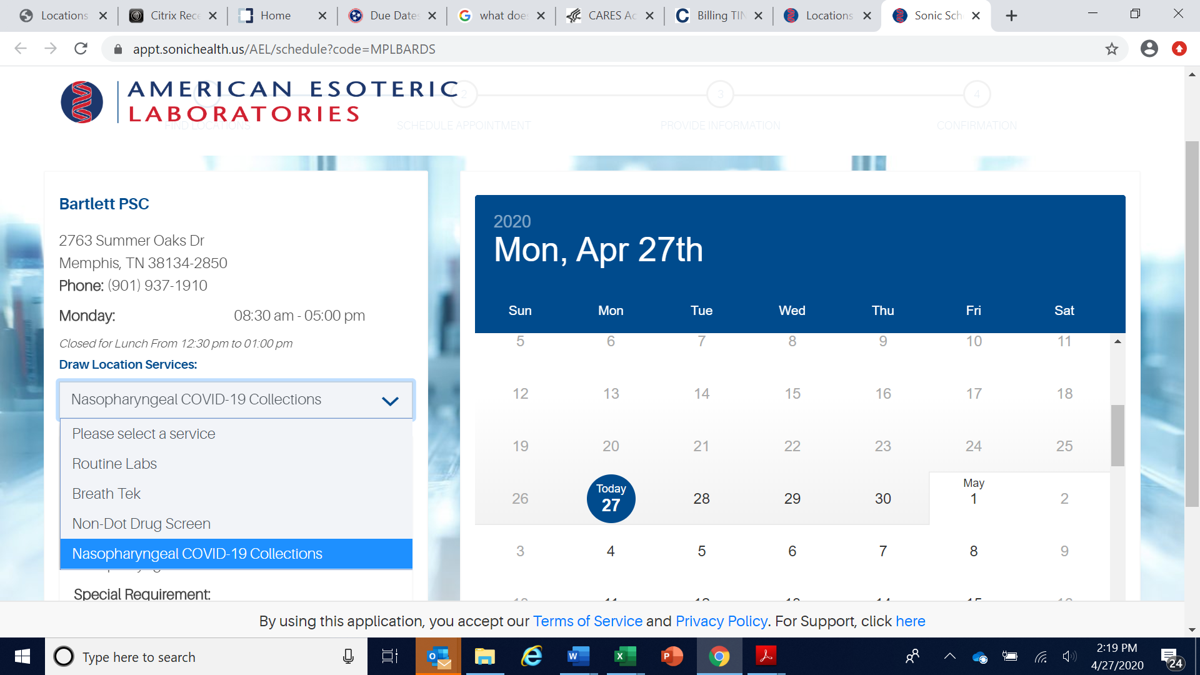
Select your desired date and time on the right-hand side and click “Next”
**YOUR SELECTION DATE MUST BE NO MORE THAN 4 DAYS (96HRS) BEFORE YOUR SURGERY DATE – FAILURE TO BOOK WITHIN THIS WINDOW WILL RESULT IN YOUR SURGERY BEING CANCELLED

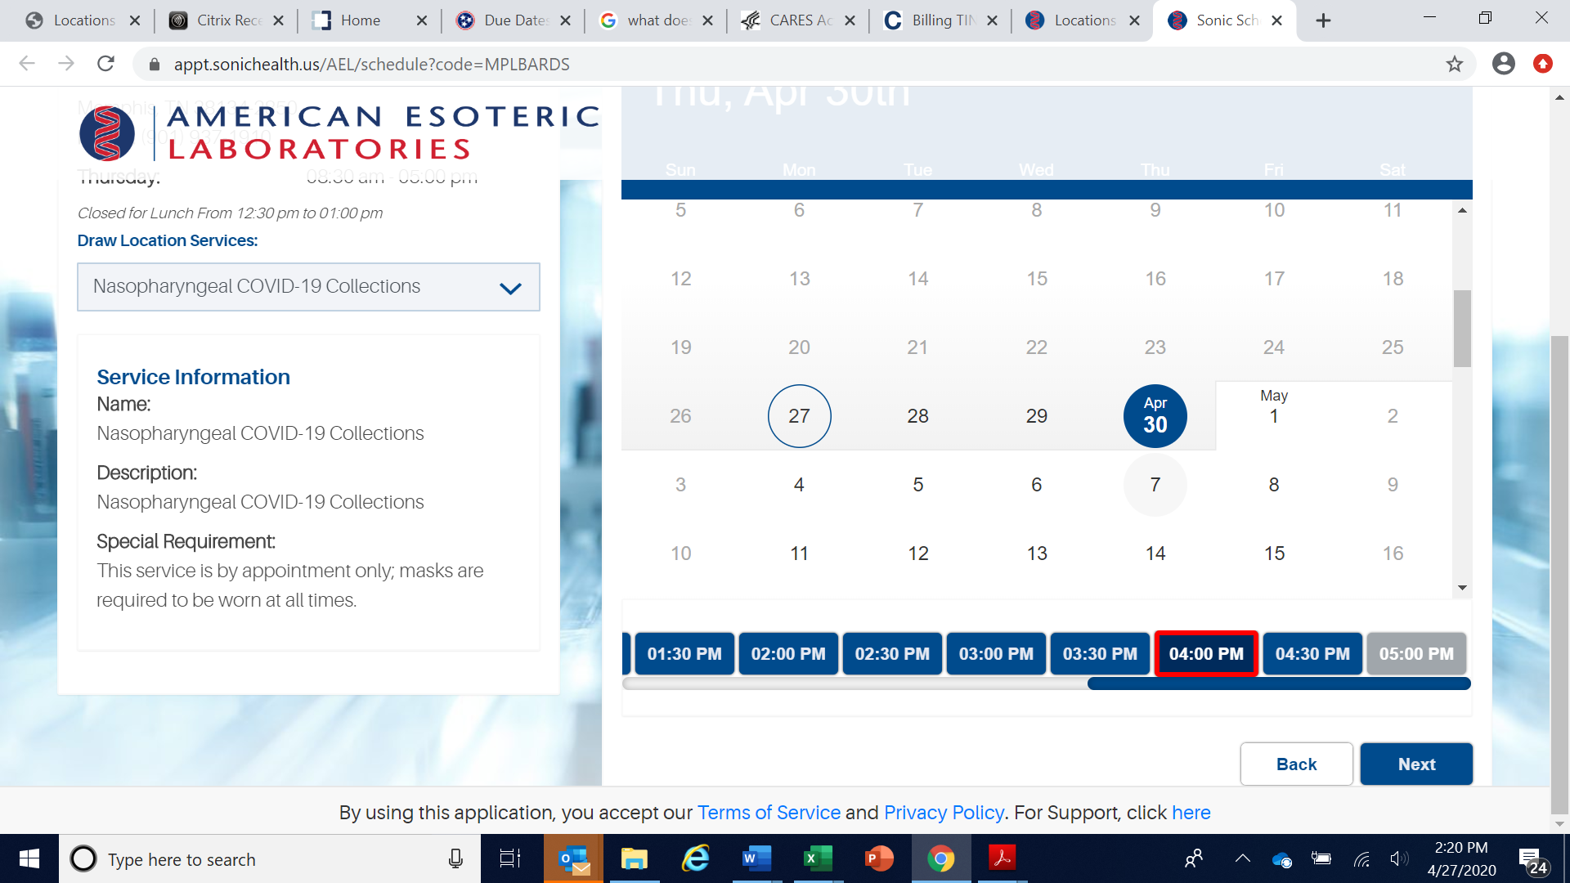
Enter your information and click “Next”
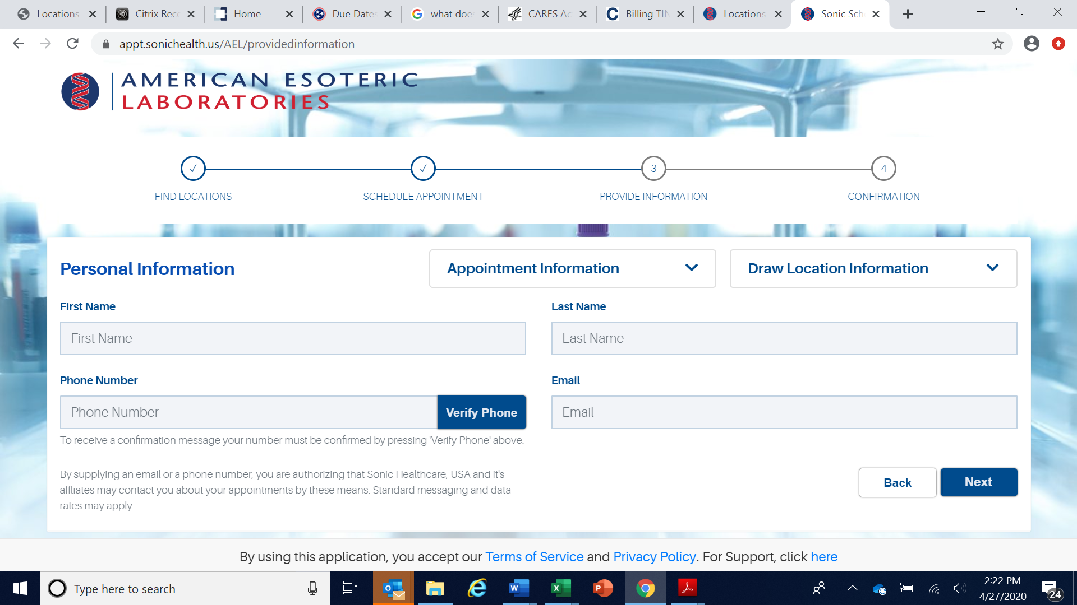
Click the box next to “I agree to the terms…” and click “schedule” to confirm your appointment

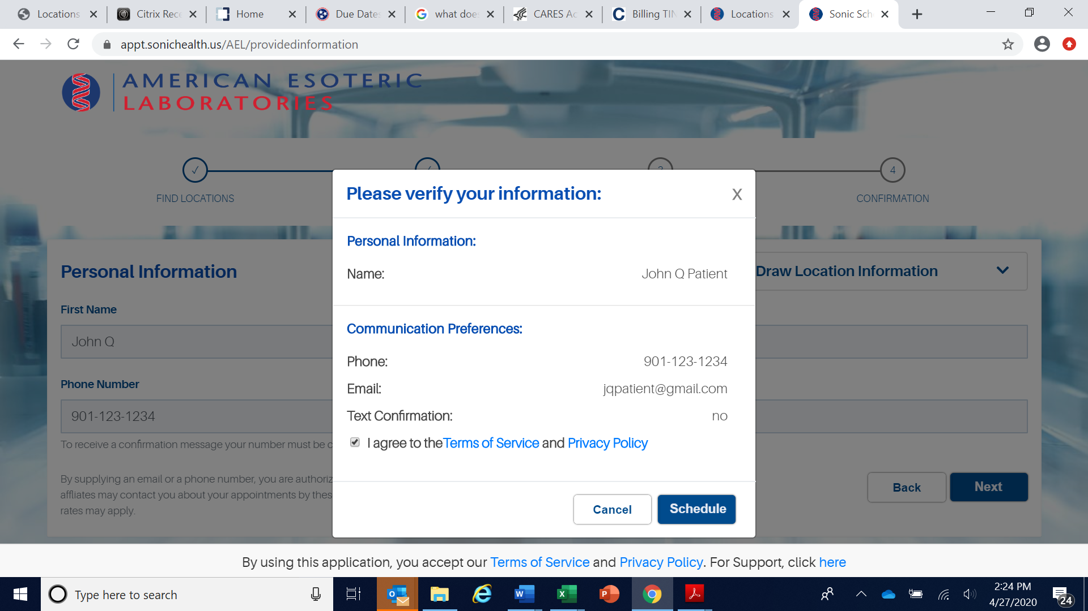

All appointments must be booked at minimum two (2) hours in advance
Results take up to 48hrs to be processed and must be received by the surgery center prior to your scheduled surgery date.
You must present your physician signed OrthoSouth Laboratory Order form, copy of your driver’s license as well as your insurance card for COVID-19 testing to be performed
**YOUR SELECTION DATE MUST BE NO MORE THAN 4 DAYS (96HRS) BEFORE YOUR SURGERY DATE – FAILURE TO BOOK WITHIN THIS WINDOW WILL RESULT IN YOUR SURGERY BEING CANCELLED

